Feature Plan

Based on our research, the website’s features will be implemented with as much simplicity as possible, whilst allowing a clean and intuitive UI. The main page is mostly dedicated to logging in or signing up to the website, with links to essential areas of the webpage. Upon logging in, a user is shown a specific landing page based on what kind of user they are (regular user/venue manager). From there, a regular user can view hotspots and whether they have visited any hotspots, while the venue manager can see information about their venue i.e., the number of people who have checked in recently, or if anyone who has tested positive has been to the venue. Admins and health officials will have access to users’ and venues’ data, with the ability to sign up other health official accounts. All user types will be able to access and edit their own details. Users will also be able to use their mobile to scan QR codes in order to check in to a location.

**Main Page/Login (index.html)**

* Log in forms
  + User log in
  + Venue manager log in
  + Can sign in with Google (only if they are a user or venue manager)
  + (Create something similar to Spotify login)
* Logo/image in header
  + Provide a title e.g. ‘Australia Contact Tracing’
  + Other logo (e.g. SA Health, customised logo)
* Links to subpages (either on top menu or on main page)

**Account creation (signup.html)**

* Sign up form for a user
  + Personal details - name, address, phone number etc
  + Create username and password
  + Ability to link account to Google account
  + Checkbox if you are a business owner - drop-down menu with extra inputs to provide information about the business e.g. business address, type, owner, etc.
* Provide link to login - button that displays ‘Already have an account? Log in’

**Manage user info (profiles)**

* View and edit user profile (after registration) - can edit profile regardless of what type of user they are
  + Name
  + Address
  + Postcode
  + Phone number
  + Email
  + Emergency Contact
* View places they’ve been
  + Display hotspots in a list
  + Shows any hotspots they may have been near
* Option for user to tell app they’ve been tested positive (can categorise themselves as a community-transmitted case or an overseas acquired case)

**Map**

* Shows hotspots and check-in history
  + We have a check-box so that users can select whether they want to see hotspots, check-in history or both
* Map of hotspots to be displayed
  + User hovers over the location - hotspot name, address, etc. is displayed
* Check-in history
  + Pins placed on locations users have checked in
  + Highlighted/different colour pins on locations users have checked in that is a hotspot - allows users to check if they’ve been to a hotspot

**Venue Owner/Manager**

* Displays venue information
  + Warning if someone that had been in the venue in the last week has tested positive for COVID
  + Access information on everyone who has visited the venue in the last week
* Manage venue information
  + Edit details (e.g. address)

**Admin/Health Official**

* Manage own account and other health official accounts
  + Can sign up another admin if required
* Access user data
  + Access to accounts of users - view account information and check-in history
* Access venue data
  + See current hotspots
  + Ability to mark location as hotspot or manage current hotspot areas, add information to hotspot such as hours/times someone has visited a hotspot

**QR Code Scan**

* User is prompted to open QR scanner on smartphone to scan QR code - replace unique code
* Once QR code is scanned
  + If scan is successful, will display confirmation screen
  + Check-in details will display e.g. time, date, venue, etc.
  + Check-in will be added to user profile

**Main login screen**

This will be our main login screen. Users login with a username and password, and are given the option to register an account or sign in with Google. The website heading is clearly displayed at the top, and the login form is kept in the centre of the page for simplicity. We used a similar login design to Spotify, which we found effective in allowing users to easily login to the site.

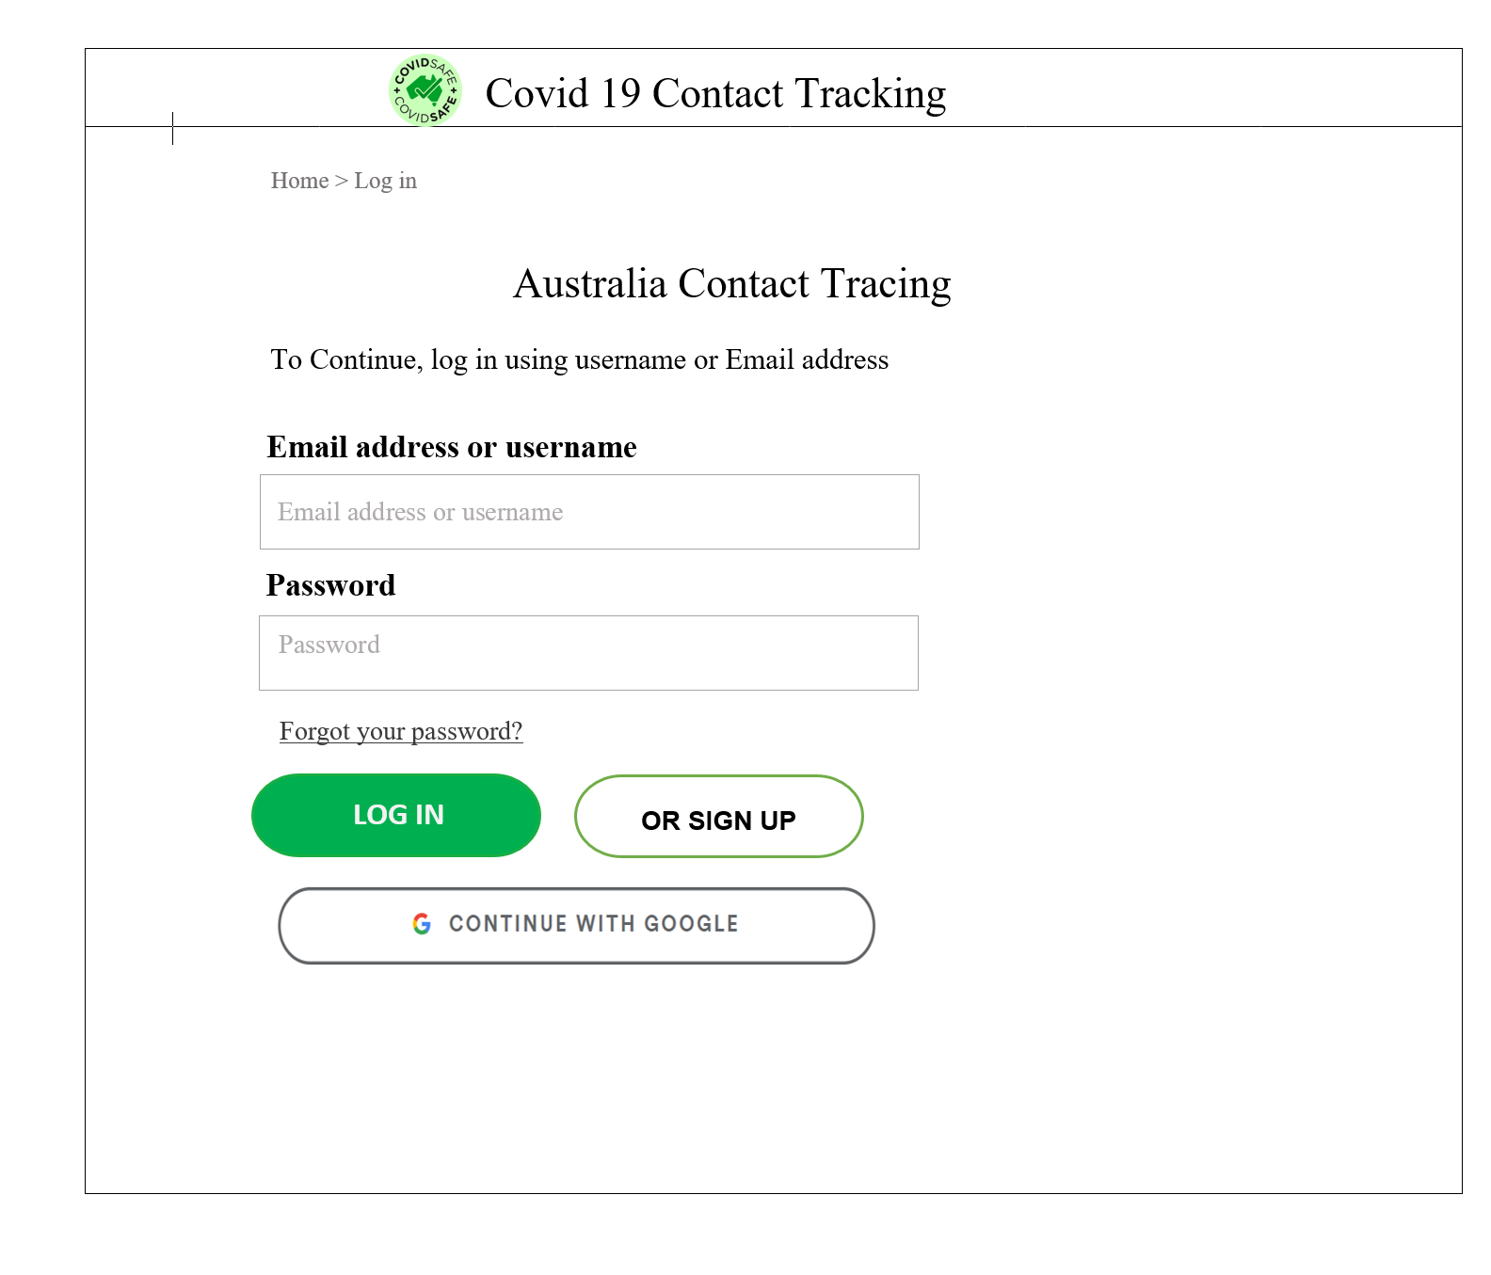

**Account creation page for users**

This page will allow a user to create an account. We will ask for the user’s first name, last name, a date of birth, username (which is an email address) and a password. Finally, we will ask the user who they are - whether they are a user or venue owner. If they are a user, then they can complete their registration. If they are a venue manager, they must click ‘Yes’ as we require more information from them before they register an account.

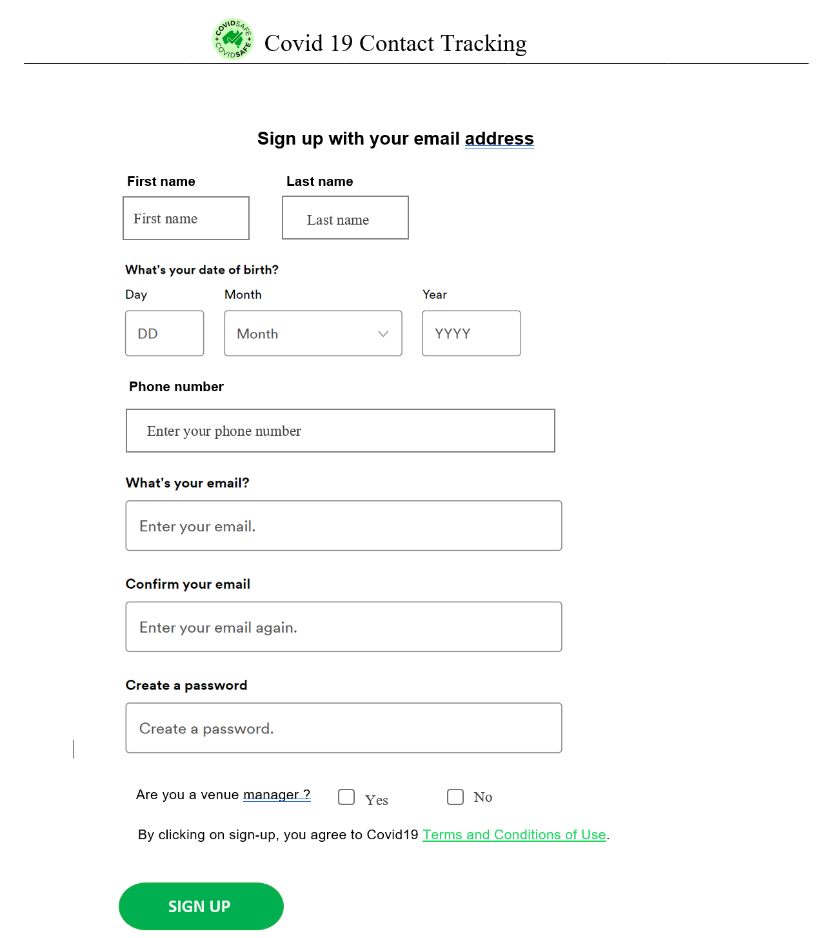

**Account creation page for venue managers**

As a venue manager, we will display a collapsible menu with extra information to enter as part of their registration. The venue manager will be asked to enter their venue name, venue contact number, address, suburb, state, and postcode.

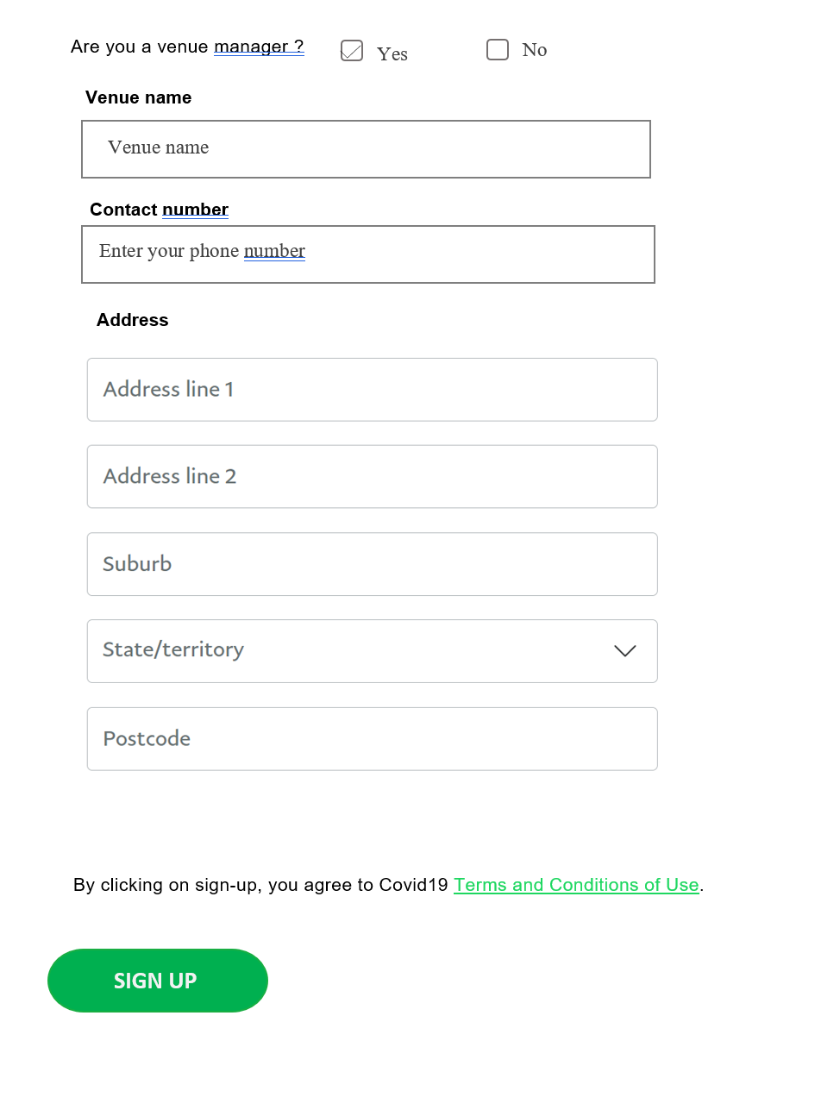

**User landing page**

The user landing page provides some basic features. Users can type the venue ID for their business or scan a QR code. If they choose to scan a QR code, they are prompted to use a QR Code scanner on their smartphone to check-in. Once the check-in is complete, a confirmation screen will appear with a list of details such as the check-in time, date, and venue location.

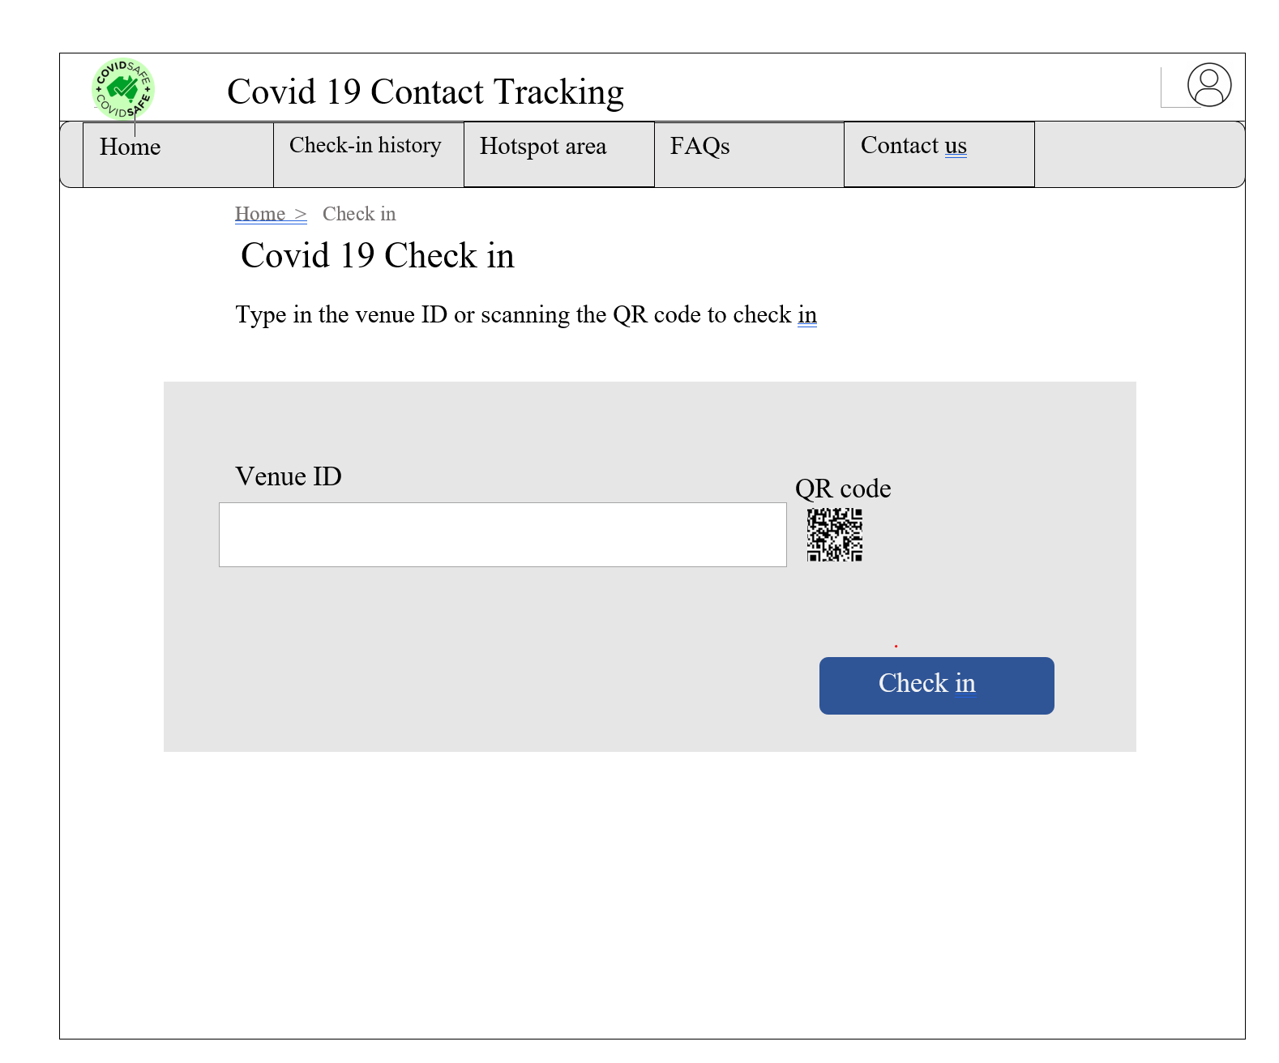

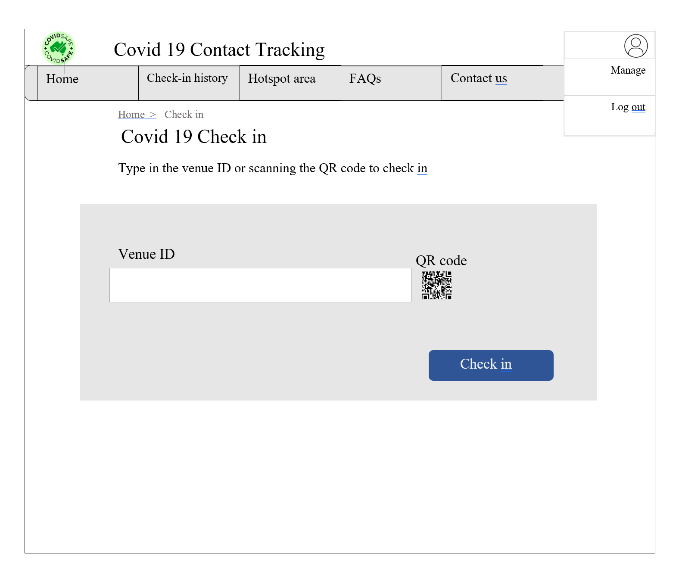

**Mobile view of the User landing page**

In the first image, when the screen size is reduced, the sign in is displayed, so that a user can check-in easily. In the second image, when the screen size is reduced, the menu will only display Home, Check-in History, Hotspot area, and FAQS. This simplified menu functionality will prevent issues with a shrunken screen size and ensure users can easily navigate the site in a mobile form.

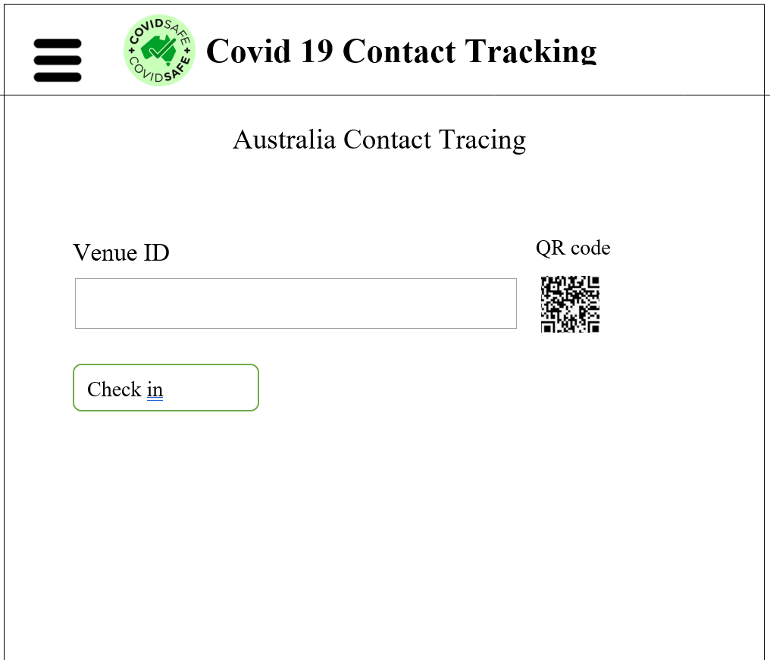

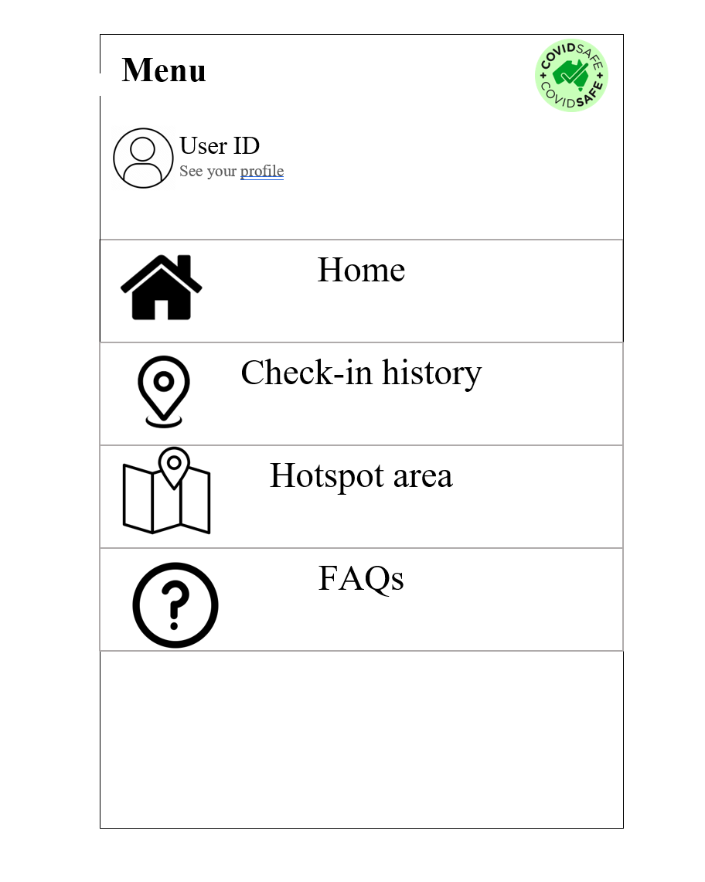

**User home page**

Normal users have the ability to check in and view hotspot areas. The Home page provides a link to allow users to check-in, provides a list of Covid statistics and a table of current Covid hotspots.

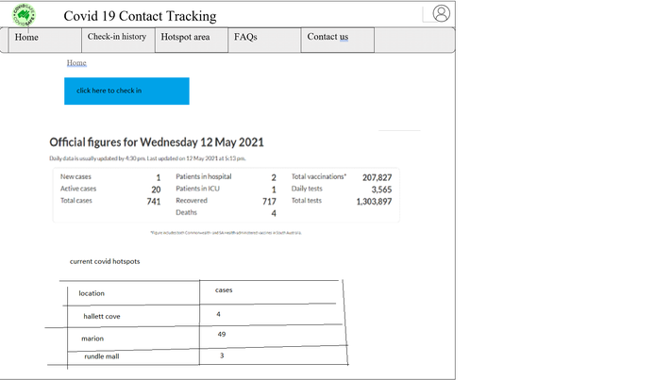

**View Check-In History**

A user can view their check-in history as shown below. The page will display a list of check-ins for the past week. The date and time of the visit is also displayed. If users want to know if their venue is a hotspot, then they can visit the ‘Hotspot area’ tab to view hotspots and check-ins in a map instead.

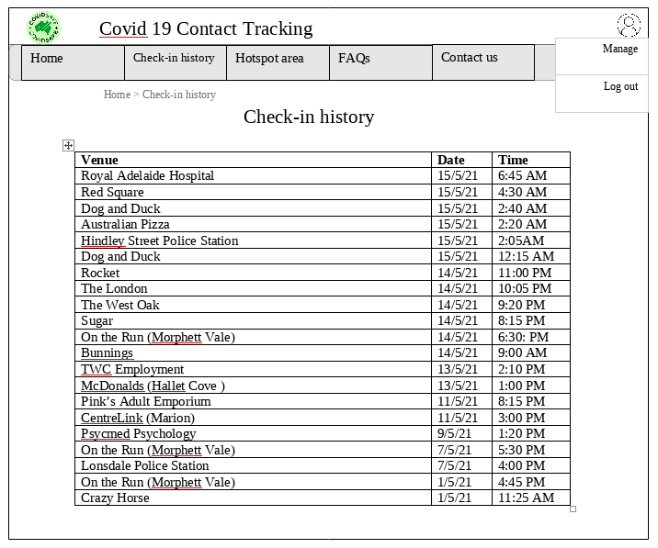

**Admin Landing Page**

Health Officials have the ability to manage users/venues, sign up other admins, update hotspots, and view/update hotspots. The Home page provides a list of Covid statistics and a table of current active cases. An admin can sort current active cases by location, most recent positive test date, and condition. They can also search active cases by name.

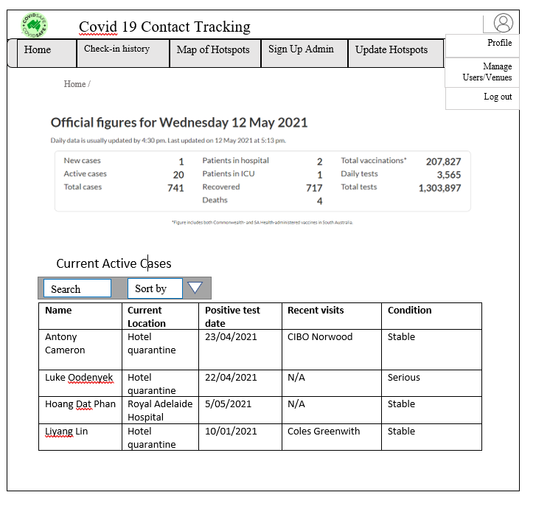

**Admin: Map of Hotspots/Check-in History page**

The Map of Hotspots page within the admin page allows you to see a map of current hotspots (MapBox API), which users can zoom in or out. Users can also hover over a hotspot and extra information about the hotspot/venue is displayed. Users can use the toggle-menu at the bottom of the page to select whether they want to view hotspots or view recent check-ins.

